**BotMother**

**A Chat-Based Forum System**

Sriram Sami / Tang Yew Siang

Github source code:<https://github.com/frizensami/botmother>

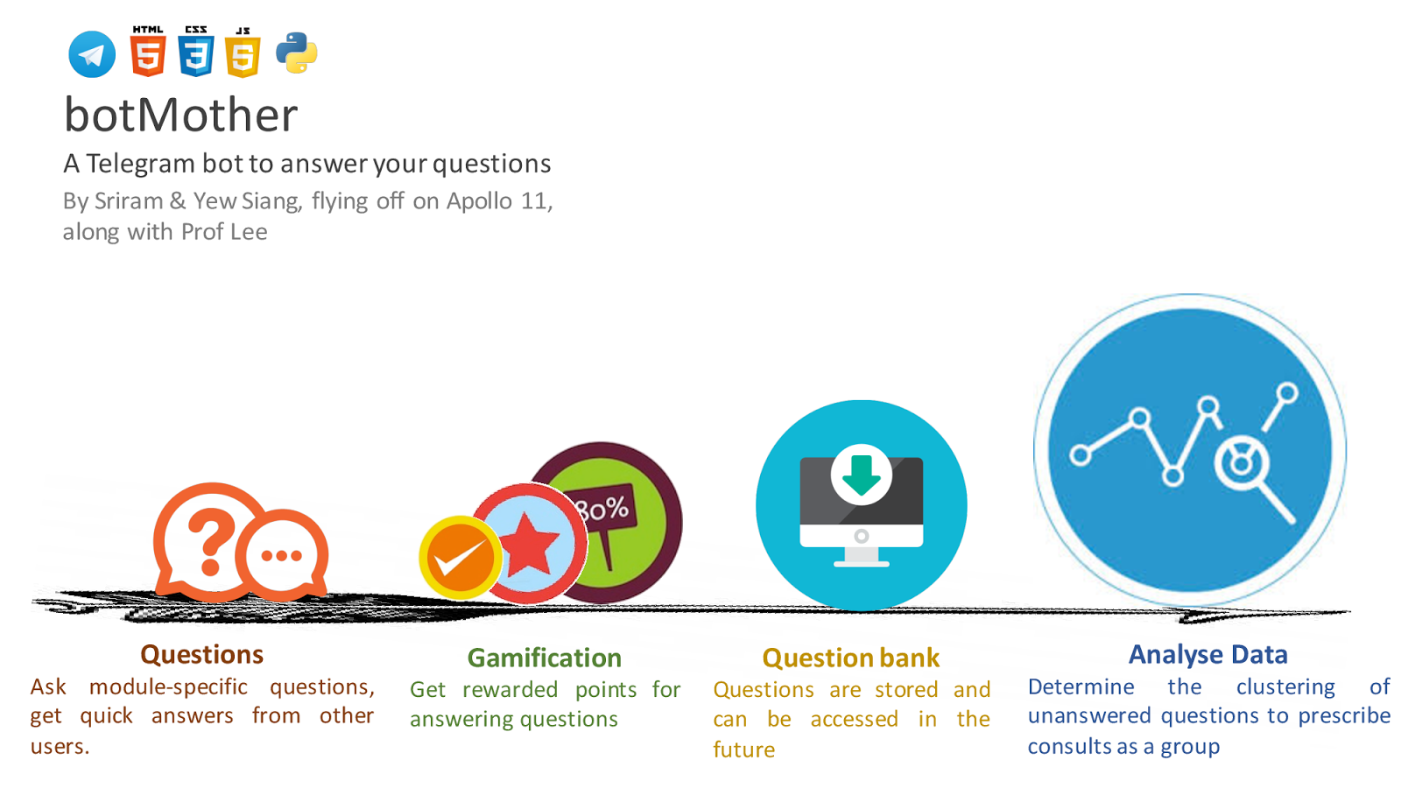

**Motivation**

When you’re stuck with a burning **question** in one of your modules, or just want **general advice** about the module itself, your current alternatives are friends, seniors and perhaps the IVLE forums.

Many may have reached the point where either their friends and seniors **don’t know** the answer, or it’s **inconvenient** to ask them, and the IVLE forums are either too **slow** a medium or it’s just strange to post your question there. The question is also **too module-specific** for Google to help you out. Also, you’re sure that someone has asked the question and gotten an answer before, so why isn’t there a record of it somewhere so you don’t have to waste time *asking the same thing again*?

**Aim**

We hope to make the Q&A process in forums quick and engaging through messaging platforms (e.g. Telegram).

**User Stories:**

1. As a student who has questions and problems with a module, I want to be able to ask questions and get quality answers quickly.
2. As a student who is revising for exams, i want to be able to look at the good questions and answers of the module over the years.
3. As a student, teaching assistant or professor who wishes to help students, I want to be able to answer posed questions in a timely manner.
4. As an administrator who wants to prevent abuse of the system, I want to be able to identify abusers, warn them and ban them if they continue to cause problems.

**Scope of Project:**

The **Telegram Bot** provides a chat-like interface for students to ask questions and their peers, teaching assistants or professors to answer quickly.

A **Web-based forum** will share a common database with the Telegram Bot and provide the same functionality with a traditional non-chat-based interface.

Features to be completed by the mid of June:

1. Telegram Bot
   1. Allow users to ask, answer, vote on module-specific questions
   2. Display **new** questions and answers

The Telegram bot has limited features (cannot display all questions and answers, cannot comment) due to limited screen space and the potential notification spam.

1. Web-based forum
   1. Allow users to ask, answer, vote and **comment** on module-specific questions
   2. Display **all** questions, answers and comments
2. Mechanisms to collect datasets to allow for analysis

Features to be completed by the mid of July:

1. Gamification system
   1. Reward users with points for good questions and answers
2. Providing recommendations with machine learning

**How are we different from similar platforms?**

1. IVLE Forums

* As BotMother does not require your NUSNET account, questions are not tagged to your real name if you choose so.  Also, we plan to give you fast-paced responses due to the nature of a primarily **chat-based** forum system, as opposed to a more static medium.

1. StackOverflow/StackExchange

* We encourage questions about homework which are frowned upon in these traditional online forums. In fact, module-specific questions are the backbone of the platform.

1. Quora

* Questions asked here can be too general

**Program Flow**

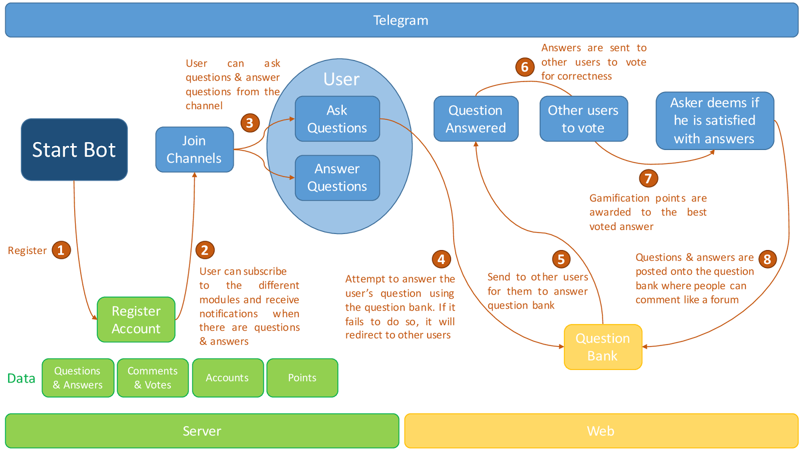

**Providing Recommendations with Machine Learning**

Over time, two things happen in our system:

* Reliable questions and answers are stored in the question bank
* Users who ask questions receive recommended answers from the question bank and can indicate if the recommended answer is relevant, correct and precise.

We constantly run a machine learning algorithm that looks at these three parameters: i.e.

* the **question being asked,**
* the **question and** **answer being recommended** as most relevant, and
* **the user’s rating of the provided recommendation**

and improves its model of *“what is a relevant answer?”* This, over time, helps the system provide increasingly more accurate recommendations.

**Proposed Level of Achievement**

Apollo 11

**What we've Done**

For the past 2 months, we have been working heavily on creating the backend that will support the functionalities of the Telegram bot and the website as well as the Telegram bot which handles the interaction with the User.

**Progress:**

1) Telegram Bot - 90% done  
Supported features:  
- Subscribe to modules  
- Asking & answering questions  
- Vote on answers  
2) Backend API - 80% done  
Supported features:  
- Database models for Users, Modules, Questions, Answers, Votes to support Telegram bot and Web functionalities  
- Functions that can be called to retrieve or manipulate data from the Telegram bot or Web  
3) Website - 30% done   
Supported features:  
- Browsing questions & answers

**Telegram Bot:**

The following screenshots shall demonstrate how a User can use the Telegram bot to 1) Ask questions, 2) Answer questions & 3) Vote on quality of the answers  
  
To get **started**

|  |  |  |  |
| --- | --- | --- | --- |
| **Getting Started** | **"/start" Command** | **"/modules" Command** | **"/BOBO1000" Command** |
| **http://i.imgur.com/rgxaVff.png** | **http://i.imgur.com/S57pI1R.png** | **http://i.imgur.com/IyOTVa5.png** | **http://i.imgur.com/sEof016.png** |
| Starting page of a Telegram bot that describes the features of your bot | The bot responds to "/start" by telling the Curious Cat what he can do with  the bot | The bot responds to "/modules" by finding available modules to subscribe to | "/BOBO1000" subscribes Curious Cat to BOBO1000 module |

Say, we have **Curious Cat** who wants to ask a question

|  |  |  |
| --- | --- | --- |
| **"/ask" Command** | **Sending the Question** | **Selecting the Module** |
| http://i.imgur.com/i5xjiuc.png | http://i.imgur.com/FpxBjGB.png | http://i.imgur.com/AUkL3s2.png |
| Curious Cat types "/ask" to prompt the bot  to ask questions | After which, Curious Cat asks the question and the bot will ask which module to send  the question to | After Curious Cat selects a module, the question will be sent! |

And **Helpful Horse** who wants to answer a question

|  |  |  |  |
| --- | --- | --- | --- |
| **Received a Question!!** | **"Answer Question" clicked** | **Confirmation of Answer** | **Sending of Answer** |
| http://i.imgur.com/v6R4CPy.png | http://i.imgur.com/PQRBFvu.png | http://i.imgur.com/cr9qTVF.png | http://i.imgur.com/qX0agFt.png |
| Helpful Horse receives a question! | He clicks on the "Answer Question" button and types his answer! | The bot checks with Helpful Horse to confirm if that is his answer | Helpful Horse clicks "Yes" and the answer is sent! |

And **Bystander Bear** who just wants to vote on an answer

|  |  |  |
| --- | --- | --- |
| **Received Question & Answers!** | **"Vote" clicked** | **Sending of Vote** |
| http://i.imgur.com/hSzQrK9.png | http://i.imgur.com/XX0U7eg.png | http://i.imgur.com/JizAVeq.png |
| Question and answers are received by  Bystander Bear | He clicks on "Vote" as he knows that number 2 is a good answer! | He clicks on "2" and the vote is sent! |

After the votes have **concluded**

|  |  |
| --- | --- |
| **Question, Answers and Votes** **are sent to the people who** **took part!** | **A link is provided for the** **people to take the discussion** **to the Web forum!** |
| http://i.imgur.com/xu5dXde.png | http://i.imgur.com/M5fQmkL.png |

**Website (Beta):**



**Testing**

**Automated Testing**

In order to cater for constant changes to our code without having to worry about certain parts breaking, we have adopted unit testing and created numerous test cases for our functions. If we unknowingly modified our function in a way that causes certain test cases to fail, we will be able to catch the problem. This allows us to change our code quickly if needed without too much worry of breaking previous functionalities.

**User Testing**

Due to the constant changes of the Telegram bot and instability due to bugs in this development phase, we have only asked a few friends to do testing. There were quite some advantages to these small tests as we got some feedback:   
  
1) They found that our bot is not very intuitive to navigate around due to the lack of prompts on what exactly they can do.   
- Problem was solved quite easily by giving constant visual feedback when Users send messages to the bot.  
  
2) During the User's interaction with the bot, we found out ways that can help to smoothen the User's experience.  
- For example, when the User wants to ask a question, he has to type out his question AND then the module in which he wants to send his question to. Previously, the User has to manually type out the module (E.g "/CS1010").   
- We realised that this is a huge hassle and executed a database query for the User and print out the modules that he has already subscribed to so that he just has to simply click on the "/CS1010". There are some disadvantages in that the message will need a slightly longer time to be transmitted. However, the User's experience is much smoother, it was a good tradeoff.

3) Due to some lag in the transmission and receiving of data, Users may have to wait 2 seconds before the button responds.  
- Problem is highly undesirable because of the experience of having to wait for buttons to respond is not pleasant  
- However, this problem is also hard to solve because there are several hidden layers of abstraction between the click of a button and the response to change the button's status.   
- This problem is a good-to-solve but not necessary-to-solve, it will have to wait for the other more important features before we come back to it.  
  
4) There is some uncertainty with regards to how to use a Telegram bot efficiently (Example, "/" commands such as "/modules" can be easily clicked on Telegram but some people do not know about this. They try to type "/modules" instead of clicking it. This becomes quite a slow and painful process)  
- This can be a hard problem to solve since it stems from the lack of understanding of how to use a Telegram bot. Similar to point 3 though, this is a problem that can be good-to-solve but not necessary-to-solve. We will focus on other features first.

Now that the Telegram bot is mostly complete and there are fewer bugs, we will be asking our friends to play around with the Bot so that they can give us more feedback!

**The Final Sprint**

We have a few features left to be implemented before we intend to release it for the general population of students to use.  
Hopefully, we can finish the core features by the 2nd week of July so that freshies can try the bot out and unleash their questions on the bot.  
  
Core features left:

1) Authentication and integration between Web and Telegram bot   
- Important feature that allows us to understand the link between the Web Users and the Telegram Users. Currently, Telegram Users can simply start a conversation with our bot with a "/start" and start asking questions immediately. In the background, we will create an account for them.   
- However, what happens if they go into the Web? We will not be able to establish the link between what they are doing on Telegram and what they are doing on the Web. Hence, we will not be able to keep track of the questions they've asked, the answers and comments they've gived and the points that they've gathered. This will not be a particularly good User Experience. Hence, this is the next feature that we have to focus on.

2) Website  
- The website's skeleton for designing is up and wiring with the backend is also done. We have to finish the rest of the website and make it presentable.

3) Gamification  
- To add some thrill for those who are asking and answering the questions!  
- We may intend to reward answerers who are very helpful with vouchers.

4) Logging  
- Before deployment, we will have to create logs for the server so that in the event of a crash, we will be able to debug and understand what went wrong from the logs.

Delayed features (can be done in the last 2 weeks of July):

1) Admin Panel  
- This feature helps the administrators to monitor the bot much easily since a GUI can be really helpful when there are many modules, questions and answers.  
- Not as urgent a feature as the core features above. We can release the bot to Users and then continue to work on this feature.

2) Machine learning  
- To improve the experience that Users will have with the bot and website.  
- This is only feasible when there are data for us to process. Hence, we can afford to finish the rest of the features and release the bot before we work on this final feature.

**Project Log**

|  |  |  |  |  |  |
| --- | --- | --- | --- | --- | --- |
| S/N | Task | Date | Sriram (hrs) | Yew Siang (hrs) | Remarks |
| 1 | Liftoff Day 1 | 9/5/2016 | 8 | 8 | Liftoff Day 1 |
| 2 | Liftoff Day 2 | 10/5/2016 | 8 | 8 | Liftoff Day 2 |
| 3 | Team meeting & initial planning | 14/5/2016 | 10 | 10 | 1) Layout the full idea for the project and the technology required  2) Delegated roles  3) Asked friends for feedback |
| 4 | Team meeting: Implementation details and initial project structure | 15/5/2016 | 12 | 12 | 1) Discussed implementation features in depth  2) Begin to create project structure, version control and test framework  3) At night: Model creation, database schema, Accounts module |
| 5 | Mission Control | 17/5/2016 | 1 | 1 | 1) Met with mentor Prof Lee Wee Sun to discuss our ideas and the possible implementation of machine learning |
| 6 | Programming at home:  Backend & Telegram Bot | 21/5/2016 | 2 | 2 | 1) Develop database models  2) Handle simple telegram messages |
| 7 | Programming at home:  Backend & Telegram Bot | 22/5/2016 | 4 | 4 | 1) Develop database models  2) Handle simple telegram messages |
| 8 | Programming at home:  Backend & Telegram Bot | 23/5/2016 | 1 | 1 | 1) Develop database models  2) Developed skeleton to handle telegram messages that use callbacks |
| 9 | Programming at home:  Backend & Telegram Bot | 24/5/2016 | 2 | 2 | 1) Backend API  2) Debugging problem that has to do with Telegram callback functions |
| 10 | Team meeting | 28/5/2016 | 10 | 10 | 1) Worked on Milestones  2) Backend API  3) Supporting more Telegram commands |
| 11 | Programming at home:  Backend & Telegram Bot | 4/6/2016 | 10 | 10 |  |
| 12 | Programming at home:  Backend & Telegram Bot | 5/6/2016 | 10 | 10 |  |

|  |  |  |
| --- | --- | --- |
| Total Hours | Sriram | Yew Siang |
|  |  |  |

Project Log

Milestone 1

|  |  |  |  |  |  |
| --- | --- | --- | --- | --- | --- |
| S/N | Task | Date | Sriram (hrs) | Yew Siang (hrs) | Remarks |
| 1 | Liftoff Day 1 | 9/5/2016 | 8 | 8 | Liftoff Day 1 |
| 2 | Liftoff Day 2 | 10/5/2016 | 8 | 8 | Liftoff Day 2 |
| 3 | Team meeting & initial planning | 14/5/2016 | 10 | 10 | 1) Layout the full idea for the project and the technology required  2) Delegated roles  3) Asked friends for feedback |
| 4 | Team meeting: Implementation details and initial project structure | 15/5/2016 | 12 | 12 | 1) Discussed implementation features in depth  2) Begin to create project structure, version control and test framework  3) At night: Model creation, database schema, Accounts module |
| 5 | Mission Control | 17/5/2016 | 1 | 1 | 1) Met with mentor Prof Lee Wee Sun to discuss our ideas and the possible implementation of machine learning |
| 6 | Programming at home:  Backend & Telegram Bot | 21/5/2016 | 2 | 2 | 1) Develop database models  2) Handle simple telegram messages  3) Write test cases for backend |
| 7 | Programming at home:  Backend & Telegram Bot | 22/5/2016 | 4 | 4 | 1) Develop database models  2) Handle simple telegram messages  3) Write test cases for backend |
| 8 | Programming at home:  Backend & Telegram Bot | 23/5/2016 | 1 | 1 | 1) Develop database models  2) Developed skeleton to handle telegram messages that use callbacks  3) Write test cases for backend |
| 9 | Programming at home:  Backend & Telegram Bot | 24/5/2016 | 2 | 2 | 1) Develop different database functions  2) Developed  3) Write test cases for backend |
| 10 | Team meeting: Milestone 1 | 28/5/2016 | 10 | 10 | 1) Worked on Milestones  2) Backend API  3) Supporting more Telegram commands |

Milestone 2

|  |  |  |  |  |  |
| --- | --- | --- | --- | --- | --- |
| S/N | Task | Date | Sriram  (hrs) | Yew  Siang  (hrs) | Remarks |
| 1 | Team meeting:  Website & Telegram Bot | 4/6/2016 | 6 | 6 | 1) Setup frontend development tools such as  Semantic UI  2) Users can now answer questions and they will be sent to other Users. |
| 2 | Team meeting:  Website & Telegram Bot | 5/6/2016 | 8 | 8 | 1) Building templates to allow convenient access to UI elements  2) Wiring of UI elements to backend 3) Users can now vote on the answers of other Users. |
| 3 | Team meeting:  Website & Telegram Bot | 11/6/2016 | 8 | 8 | 1) Designing the website using CSS styling and Semantic UI's classes  2) The full combination of Question, Answer  and Votes can now be sent to other Users. |
| 4 | Programming at home:  Website & Telegram Bot | 12/6/2016 | 10 | 10 | 1) Designing the website using CSS styling  and Semantic UI's classes  2) Implementing feature that allows functions  to be executed only after a certain period of  time. This gives time for people to answer and vote on questions before they are sent. |
| 5 | Team meeting:  Website & Telegram Bot | 18/6/2016 | 8 | 8 | 1) Authentication of Users and establishing a link between Telegram users and Web users  2) Refactoring of Telegram bot code to ensure  modularity |
| 6 | Team meeting:  Milestone 2 | 26/6/2016 | 8 | 8 | 1) Worked on Milestones (Logs and Video) |

|  |  |  |
| --- | --- | --- |
| Total Hours | Sriram | Yew Siang |
| 212 | 106 | 106 |